SQL SHOW PROCESSLIST

📘 What is SHOW PROCESSLIST?
# Source: AI Source: Provided by: [Data Path: Persons Table -> ID Column: 1, Name_En Column: Motasem Essam] -> From: [ChatGPT] on [6/11/2026]
The SHOW PROCESSLIST command in MySQL displays a list of currently active threads (connections) running on the MySQL server. It's a key tool for monitoring performance, detecting long-running queries, or spotting blocking issues.

✅ Purpose:
# Source: AI Source: Provided by: [Data Path: Persons Table -> ID Column: 1, Name_En Column: Motasem Essam] -> From: [ChatGPT] on [6/11/2026]
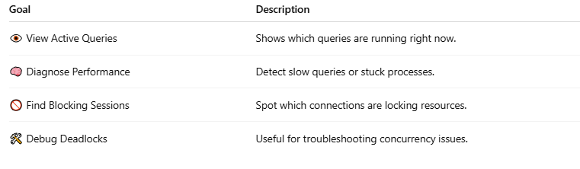
Goal | Description
👁️ View Active Queries | Shows which queries are running right now.
🧠 Diagnose Performance | Detect slow queries or stuck processes.
🚫 Find Blocking Sessions | Spot which connections are locking resources.
🛠️ Debug Deadlocks | Useful for troubleshooting concurrency issues.

🛠️ Syntax:
# Source: AI Source: Provided by: [Data Path: Persons Table -> ID Column: 1, Name_En Column: Motasem Essam] -> From: [ChatGPT] on [6/11/2026]
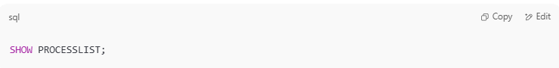
SHOW PROCESSLIST;

🔐 Full Privileges:
# Source: AI Source: Provided by: [Data Path: Persons Table -> ID Column: 1, Name_En Column: Motasem Essam] -> From: [ChatGPT] on [6/11/2026]
If you are not a SUPER or PROCESS privilege user, you'll only see your own threads.
To see all users' processes:
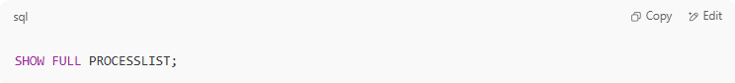
SHOW FULL PROCESSLIST;

📊 Sample Output:
# Source: AI Source: Provided by: [Data Path: Persons Table -> ID Column: 1, Name_En Column: Motasem Essam] -> From: [ChatGPT] on [6/11/2026]
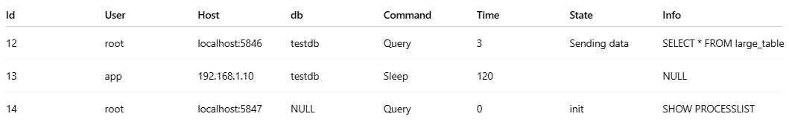
Id | User | Host | db | Command | Time | State | Info
12 | root | localhost:5846 | testdb | Query | 3 | Sending data | SELECT * FROM large_table
13 | app | 192.168.1.10 | testdb | Sleep | 120 |  | NULL
14 | root | localhost:5847 | NULL | Query | 0 | init | SHOW PROCESSLIST

🔍 Column Breakdown:
# Source: AI Source: Provided by: [Data Path: Persons Table -> ID Column: 1, Name_En Column: Motasem Essam] -> From: [ChatGPT] on [6/11/2026]
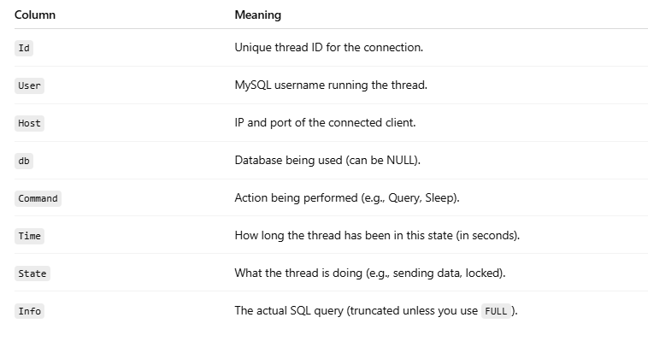
Column | Meaning
Id | Unique thread ID for the connection.
User | MySQL username running the thread.
Host | IP and port of the connected client.
db | Database being used (can be NULL).
Command | Action being performed (e.g., Query, Sleep).
Time | How long the thread has been in this state (in seconds).
State | What the thread is doing (e.g., sending data, locked).
Info | The actual SQL query (truncated unless you use FULL).

🔎 Tip: Kill a Stuck Thread
# Source: AI Source: Provided by: [Data Path: Persons Table -> ID Column: 1, Name_En Column: Motasem Essam] -> From: [ChatGPT] on [6/11/2026]
If a thread is misbehaving:
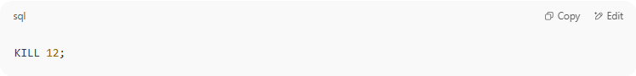
KILL 12;

Where 12 is the Id of the process.

Example

basic command
# Source: ScreenShot Source: Provided by: [Persons Table -> ID Column: 1, Name_En Column: Motasem Essam] -> Tool: [Automation Table -> ID Column: 16, Name_En Column: Screen Capture] -> From [Operating System: Wampserver64 -> phpmyadmin] on [6/11/2026]
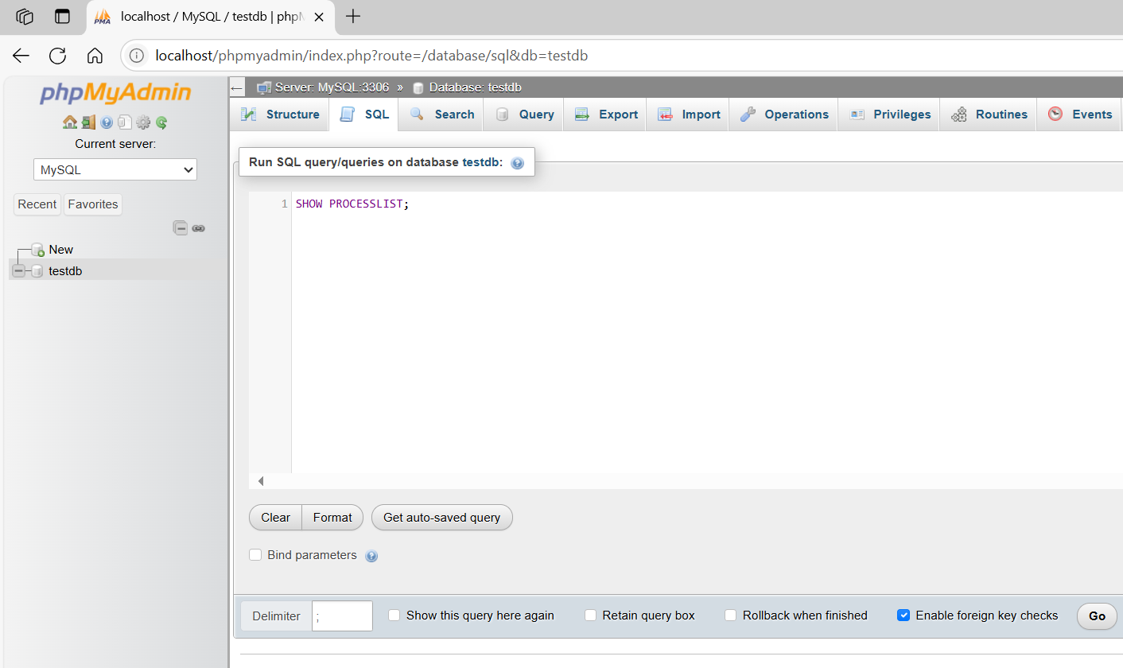
SHOW PROCESSLIST;
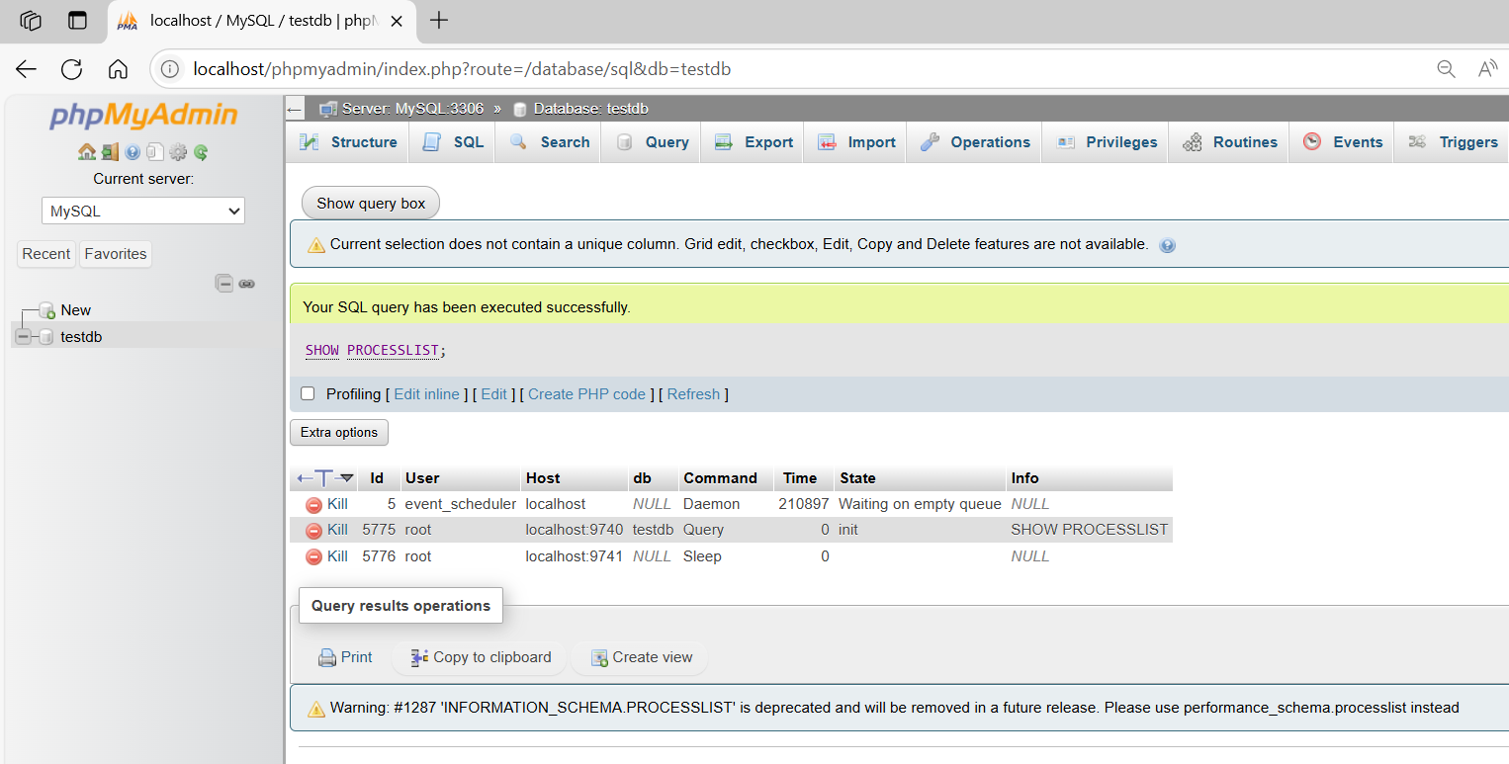

basic command
# Source: ScreenShot Source: Provided by: [Persons Table -> ID Column: 1, Name_En Column: Motasem Essam] -> Tool: [Automation Table -> ID Column: 16, Name_En Column: Screen Capture] -> From [Operating System: Wampserver64 -> phpmyadmin] on [6/11/2026]
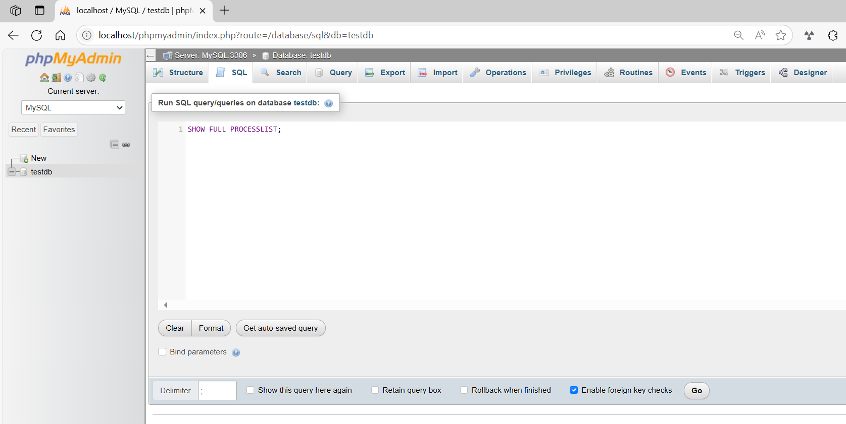
SHOW FULL PROCESSLIST;
